TURKEY-EU RELATIONS
Aim of the Course
The course aims to analyse the main issues in the relationship between Turkey and the EU. It first looks at the historical evolutions of the EU-Turkey relations and then goes to elaborate on the main problems, reasons and potentail solutions to the obstacles. It has a prospective outlook in the form of scenarios for the relationship as well.
There are several textbooks for the course to be used as a manual. Lectures will be made up of the professor’s original notes.

Textbooks:

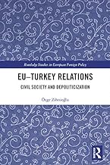

EU–Turkey Relations: Civil Society and Depoliticization (Routledge Studies in European Foreign Policy) by Özge Zihnioğlu Aug 1, 2019

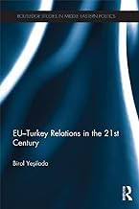

EU-Turkey Relations in the 21st Century (Routledge Studies in Middle Eastern Politics)
Part of: Routledge Studies in Middle Eastern Politics by Birol Yesilada, Feb. 2013

Assesment
35% Midterm
50% Final
15% Presentation
Week 1: Introduction to the course (10-13 February)
Ottoman Empire-European relations
Week 2: 1923-1959, 1959-1973: Ankara Agreement (17-20 February)
Week 3: Turkey-EU Relations: 1973-1995: 1980 coup d’etat (24 February-27 February)
Week 4: Customs union (2 March – 5 March)
Week 5: 1995-2004: Luxembourg, Helsinki, Copenhagen Summits (9 March – 12 March)
Week 6: 2005-2020: progress reports, Positive Agenda, What can be done? ( 16 March -19 March)
Week 7: 2005-2020: progress reports, Positive Agenda, What can be done? (23 March – 26 March)
Week 8: Midterm week (30 March-3 April
Week 9: Democratisation in Turkey-EU relations (6 April-9 April)
Week 10: Importance of economy in Turkey-EU Relations; with special focus on customs union and agriculturel (13-16 April)
Week 11: Role of religion in Turkey-EU Relations (20-23 April): no articles for this week
Week 12: Germany and Turkey-EU Relations (30 April) : no articles for this week
Week 13: Migration and Turkey-EU Relations (4 May-7 May)
Week 14: Importance of public opinion in Turkey-EU relations (11 May -14 May)
Week 15:2 left articles and make up lesson for 10 April (18 May-21 May)

